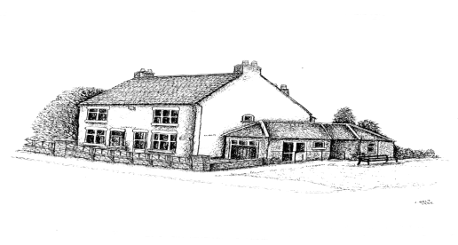
Ratby Surgery
122-124 Station Road
Ratby
Leicestershire
LE6 0JP
Tel: 0116 2394960

If you need any support in completing this form, please ask at the reception
Thank you for applying to join Ratby Surgery. We would like to gather some information about you and ask that you fill in the following questionnaire. You don’t have to supply answers to all of the questions but what you do fill in will help us give you the best possible care. Please supply two forms of Identification with your completed form, a photographic form of ID (such as passport or driving license) if you do not have photographic ID then please bring your birth certificate and proof of your home address (such as a recent bank statement or document relating to your new home with your name on).

Please complete all areas in CAPITAL LETTERS and tick the appropriate boxes. Fields marked with an asterix (*) are mandatory.
PLEASE NOTE: IF YOU ARE REGISTERING AND LIVE AT AN ADDRESS OUTSIDE OUR CATCHMENT AREA
THE DOCTORS WILL NOT BE ABLE TO PROVIDE HOME VISITS. * Please tick that you have read this note

*Title | *First names |  | * Any previous surname(s)
*Surname |  |  | Town and country of birth
*Male Female |  |  | *NHS No.  (if known)
*Date of Birth |  |  | *Home address
*Home telephone No.
*Mobile No. (if you have one) |  |  | Email address:
*Main spoken languages
English
Other (please specify)

Interpreter required?
Yes | No
Would you agree to the Practice sending you text messages when required, to remind you of an appointment or asking you to contact reception? * Yes No Answering machine messages* Yes No

You can register for online services. This would give you access to booking appointments, ordering repeat prescriptions, viewing any blood test results etc. Would you like this? *Yes No

Do you have any additional communication needs? Please state your requirements…………………………………………………………………………………………………..
………………………………………………………………………………………………………………………..
We have a hearing loop – please ask at reception for details

Previous address and doctors details

* Weight……………………………… *Height…………………………………..

Additional details about you

*What is your ethnic group? (Choose an option that best describe your ethnic group or background)

White  Black  Asian  Mixed  Other |  | English/Welsh/Scottish  Caribbean  Indian  White + Black  Please specify: |  | Northern Irish  African  Pakistani  White + African |  | Irish  Other  Chinese  White + Asian

Summary Care Record (SCR)
The SCR is a summary of your medical history that can be shared between healthcare staff treating patients in an emergency or out-of-hours with faster access to key clinical information. You can choose to share or not share your electronic records with other health care services.
(If under 16 must be answered by parent / guardian)
- Express consent for medication, allergies and adverse reactions only
- Express consent for medication. Allergies, reactions and additional information*
- Express dissent – I do not want a summary care record

* Additional information would give doctors access to your records should you need to attend another Health Care Provider e.g. hospitals, A+E which could prove invaluable in case of an emergency.

Do you have a Carer? Yes No

If yes, what is their name and contact number?
Do you consent for your carer to be informed about your medical care? Yes No

Are you a Carer? Yes No
If yes, do you look after someone who is a patient of Ratby Surgery? Yes No Don’t know

If yes, what is their name?
Are they a: Relative Friend Neighbour

Next of kin
Name of next of kin |  | Relationship to you

Next of kin telephone number(s) |  | Next of kin address (if different to above)
Please tell us about your alcohol consumption
Questions (please circle your answers) | Unit scoring system
 | 0 | 1 | 2 | 3 | 4
How often do you have a drink containing alcohol? | Never  (go to Page 4) | Monthly or less | 2 - 4 times  Per month | 2 - 4 times per week | 4+ times per week
How many units of alcohol do you drink on a typical day when you are drinking? | 1 - 2 | 3 – 4 | 5 – 6 | 7 – 9 | 10+
How often have you had 6 or more units if female, or 8 or more if male, on a single occasion in the last year? | Never | Less than monthly | Monthly | Weekly | Daily or almost daily
How often during the last year have you found that you were not able to stop drinking once you had started? | Never | Less than monthly | Monthly | Weekly | Daily or almost daily
How often during the last year you failed to do what was normally expected from you because of your drinking? | Never | Less than monthly | Monthly | Weekly | Daily or almost daily
How often during the last year have you needed an alcoholic drink in the morning to get yourself going after a heavy drinking session? | Never | Less than monthly | Monthly | Weekly | Daily or almost daily
How often during the last year have you had a feeling of guilt or remorse after drinking? | Never | Less than monthly | Monthly | Weekly | Daily or almost daily
How often during the last year have you been unable to remember what happened the night before because you had been drinking? | Never | Less than monthly | Monthly | Weekly | Daily or almost daily
Have you or somebody else been injured as a result of your drinking? | No |  | Yes, but not in the last year |  | Yes, during the last year
Has a relative or friend, Doctor or other Health worker been concerned about your drinking or suggested you cut down? | No |  | Yes, but not in the last year |  | Yes, during the last year
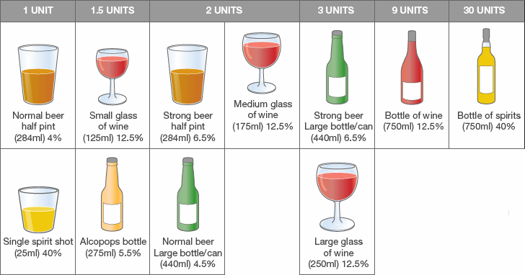

How many units of
alcohol per week?

……………………………….

Medical details (Please list any medications including HRT and contraception)

*Are you allergic to any medicines? Yes No (if yes please specify)

Looked after Children Please tell us about your smoking habits
Are you looking after someone else’s child? Yes No  If Yes, under what arrangements:  Section 20-Voluntary Care Interim Care Order  Care Order  Child arrangement order/Residence Order  Special Guardianship order Placed for adoption  Private arrangement/Private Fostering/informal arrangement  (please note you have a duty to notify social care of this arrangement) | Do you smoke?  Never Ex-smoker Smoker  If Yes, what do you primarily smoke:  Pipe Cigarettes Cigar Other  How many do you smoke a day?  Should you wish to quite please:  Call 0345 646 66 66 or visit www.quitready.co.uk

Please record any additional information about you that you think is important for us to know
(Additional information includes: Social worker involved with your family; legal parental responsibilities of minor under 16 years old; applicant is in foster care or is adopted; if you are from overseas and claiming asylum or are a refugee)

*Signed |  | *Date (dd/mm/yyyy) / /

Signed on behalf of patient (if applicable) Full Name:
(Minors under 16 years old, adults lacking capacity)
Relationship:

Thank you for providing this information. We look forward to providing you with high standard of care in a friendly and professional manner.

FOR OFFICE USE ONLY
PHOTO ID/Birth Certificate (Over 18 only) TYPE: _________________________
ADDRESS ID TYPE: _________________________
Other TYPE: _________________________

